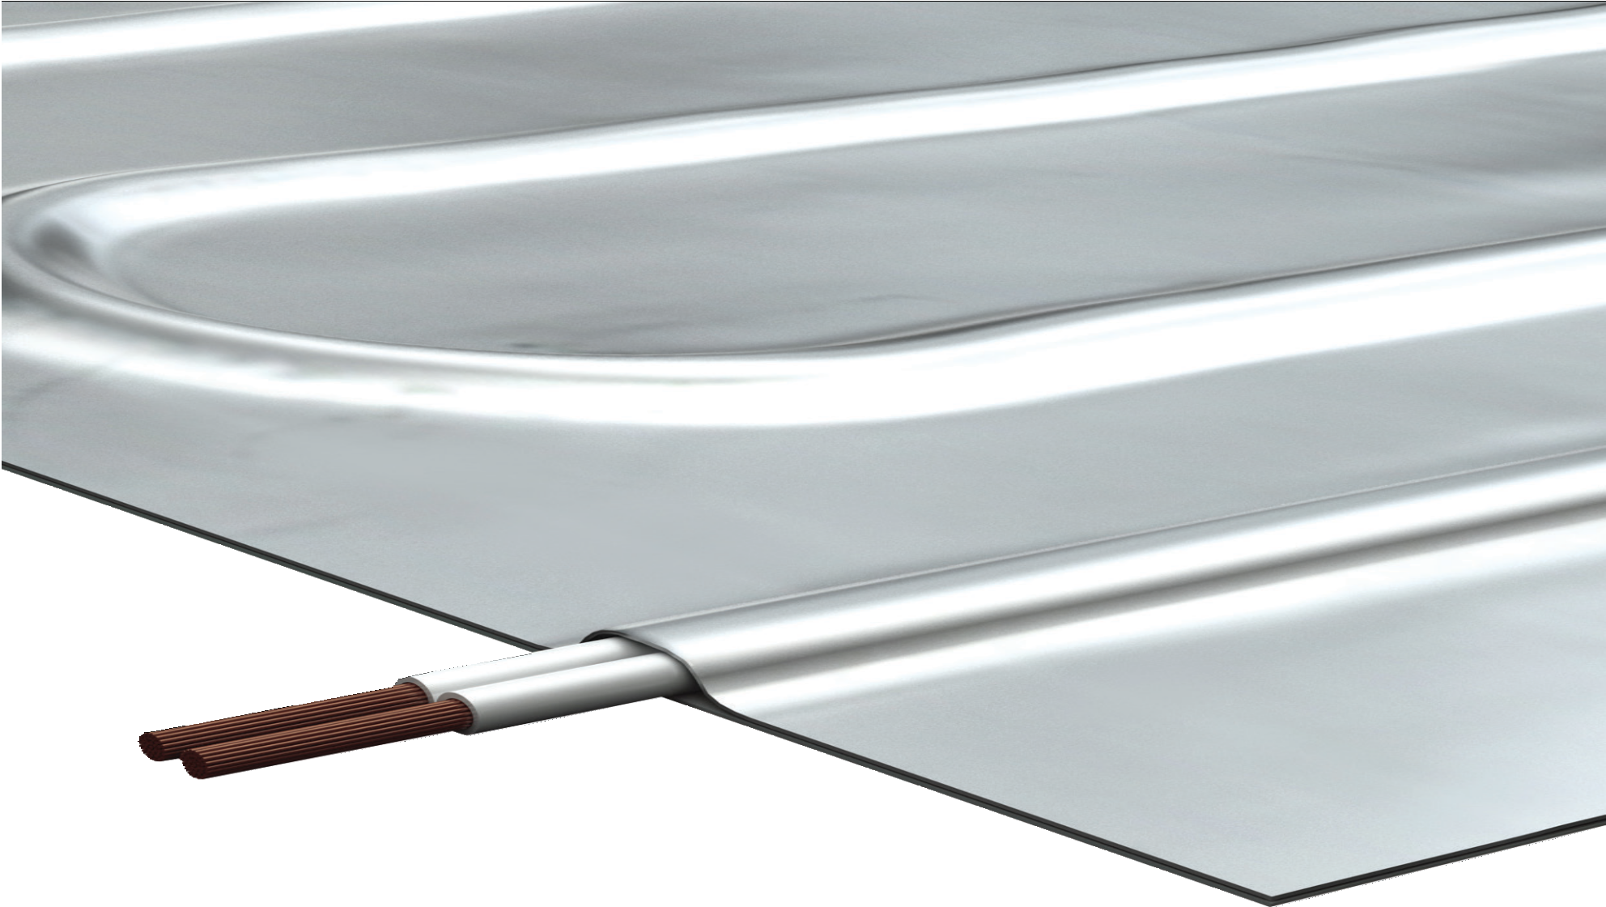
CARPET
LVT’S
US +1 (888) 927-6333 / CA 1+ (888) 592-7687
ussales@warmup.com
www.warmup.com / www.warmup.ca

ELECTRIC RADIANT FOIL SYSTEM

FOR FLOOR HEATING UNDER
FLOATING WOOD FLOORS

1.1 Section Includes

- Electric radiant floor heating mats, installed beneath carpet, vinyl or floating wood floor covering(s).

- Digital thermostat with probe type thermistor sensor.

- Electric radiant floor heating system components, accessories, and associated installation materials.

1.2 Related Sections

- 013300 – Submittal Procedures
- 014100 – Regulatory Requirements
- 014300 – Quality Assurance
- 017000 – Execution and Closeout
- 061000 – Rough Carpentry
- 096000 – Flooring
- 260620.16 – Electrical
- 260620.23 – Electrical

1.3 References

- National Electrical Code (NEC)
- Canadian Standards Association (CSA)
- Underwriter’s Laboratory (UL)
- American National Standards Institute (ANSI)
- Carpet and Rug Institute (CRI)
- Warmup Electric Radiant Foil System Installation Manual

1.4 Performance Requirements

- Electric floor heating mat must generate 12 watts per square foot. Mat heaters less than 12 watts per square foot, will not be acceptable for this application.

- Heating cables or mats that must be buried in mortar, will not be acceptable for this application.

- Underlayment should be comprised of a thin polystyrene insulation barrier with effective acoustic properties to reduce contact noise (WIU).

1.5 Submittals

- Submit under provisions of Section 013300

- Provide General Contractor, Architect, MEP Engineer, and Owner with all the Manufacturer’s product data sheets, warranty, and installation instructions.

- Provide General Contractor, Architect, MEP Engineer, and Owner with all relevant Shop Drawings, Samples, Mock-Ups, and Electrical Schematics.

1.6 Quality Assurance

- Manufacturer Qualifications & Services:
  - 20 years of experience (minimum) with electric radiant floor heating systems.
  - Floor heating mats, thermostats, sensors, relays, and related items shall be provided by one supplier.
  - Must be able to provide on-site field support, 24/7 technical installation support, and free design assistance.

- Installer Qualifications:
  - Must have verifiable experience successfully completing projects of similar size, and /or has been trained or certified by a manufacturer’s representative.
  - A licensed electrician shall complete all electrical rough-in, and electrical connections required to complete the system installation.

- Regulatory Requirements and Approvals - Electric Radiant Floor Heating System. Provide a radiant floor heating system that complies with the following requirements:
  - Heating mats for installation in cement-based mortar or over wood subfloors shall be listed to UL 1673 and CSA- C22.2 No. 130-03.

- Pre-Installation Meetings:

  - Coordinate work with other trade representatives (general, electrical, flooring, and other trade contractors) to verify areas of responsibility (scope of work).
  - Review project timeline and construction deadlines to ensure project will comply with all manufacturer’s installation instructions and warranty requirements.

1.7 Delivery, Storage and Handling

- Deliver materials in manufacturer’s original, unopened, undamaged containers with identification labels intact.

- Store materials protected from exposure to harmful site conditions, and in an area protected from vandalism and theft.

2.1 Manufacturer

A. Warmup Inc. US +1 (888) 927-6333 / CA 1+ (888) 592-7687
52 Federal Road, Unit 1F, Danbury, CT 06810 www.warmup.com/www.warmup.ca

B. Substitution requests must be approved 15 days prior to bid due date.
Alternative equipment manufacturer must provide all relevant product data sheets, warranty, installation instructions, shop drawings, samples, and electrical schematics. Alternative equipment must meet specified material standards.

2.2 Electric Radiant FOIL heating system

- The Warmup FOIL panel is an ultra-thin electric radiant heating system designed for use under laminates, LVT’s and carpet. Heat is generated by twin conductor copper alloy heating cables, with an advanced fluoropolymer (ETFE) jacket. A braided ground sheath
surrounds the twin conductors. The FOIL layers serve as a heat dissipator and as the electrical ground. The mat can be field-modified to adjut to room layouts. Each mat has a 10ft lead factory-spliced to connect to the controller.

- The Warmup FOIL Heating Mat shall be 120 VAC or 240 VAC, be UL listed and be backed by a 15 year Manufacturer’s Warranty. Multiple mat systems must be wired in parallel to the controller.

2.3 Controls, Sensors & Accessories

- The 4iE control series provide a touch-screen interface and a 7-day programmable thermostat. The 4iE-03 & 4iE-04 models are equipped with a built-in Class A GFCI protection. The 4iE-04 model provides WiFi connectivity to operate the heating system via the MyHeating app, the my.warmup.com portal or third party systems using a Control 4 bridge (provided).
All Warmup thermostats are dual voltage and supplied with a 10ft low voltage floor sensor. Each thermostat can switch up to 15Amps of load. Warmup thermostats come with a 3 year warranty.

- Insulation may be provided to prevent heat losses under the area from: concrete slab sub- floors, unheated crawl spaces, unheated garages, etc. WIU (page 2) shall be at least ¼” thick (6mm), and must be tested for thermal resistance in accordance with ASTM C 177-85 . Any flexible insulation must present a reflective FOIL backing as well as vapor barrier properties.

3.1 Manufacturer’s Instructions

A. Comply with manufacturer’s product data, including product technical bulletins, installation instructions and design drawings.

3.2 Examination & Preparation

- Installer shall verify field measurements are as shown on Shop Drawing(s).

- Any revisions needed to Shop Drawing(s), or product provided, must be corrected prior to proceeding with the installation.

- Prepare your base, as per the standard guidelines set forth by the American Society of Concrete Contractors. Remove any rip-rap, glass, or other sharp objects, that may damage the heating mat.

- Installer shall verify that the required power is available in proper location, and ready for use.

3.3 Installation

A. Complete installation must conform to appropriate manufacturer’s installation instructions, National Electrical Code, and appropriate local codes.

3.4 Field Quality Control

- Test each mat heater for ohms, with the Warmup Alligator before, during and after the instal- lation of the wood, carpet or LVT. Record these values on the warranty form provided at the end of the Warmup Installation Manual.

- Final testing of the installation resistance must be done by a licensed electrician.

- Start-up (first-time activation) may proceed immediately after testing.

- During “Start-Up”, voltage and amps should be tested by a licensed electrician

- All testing records should be copied and provided to the Owner.

