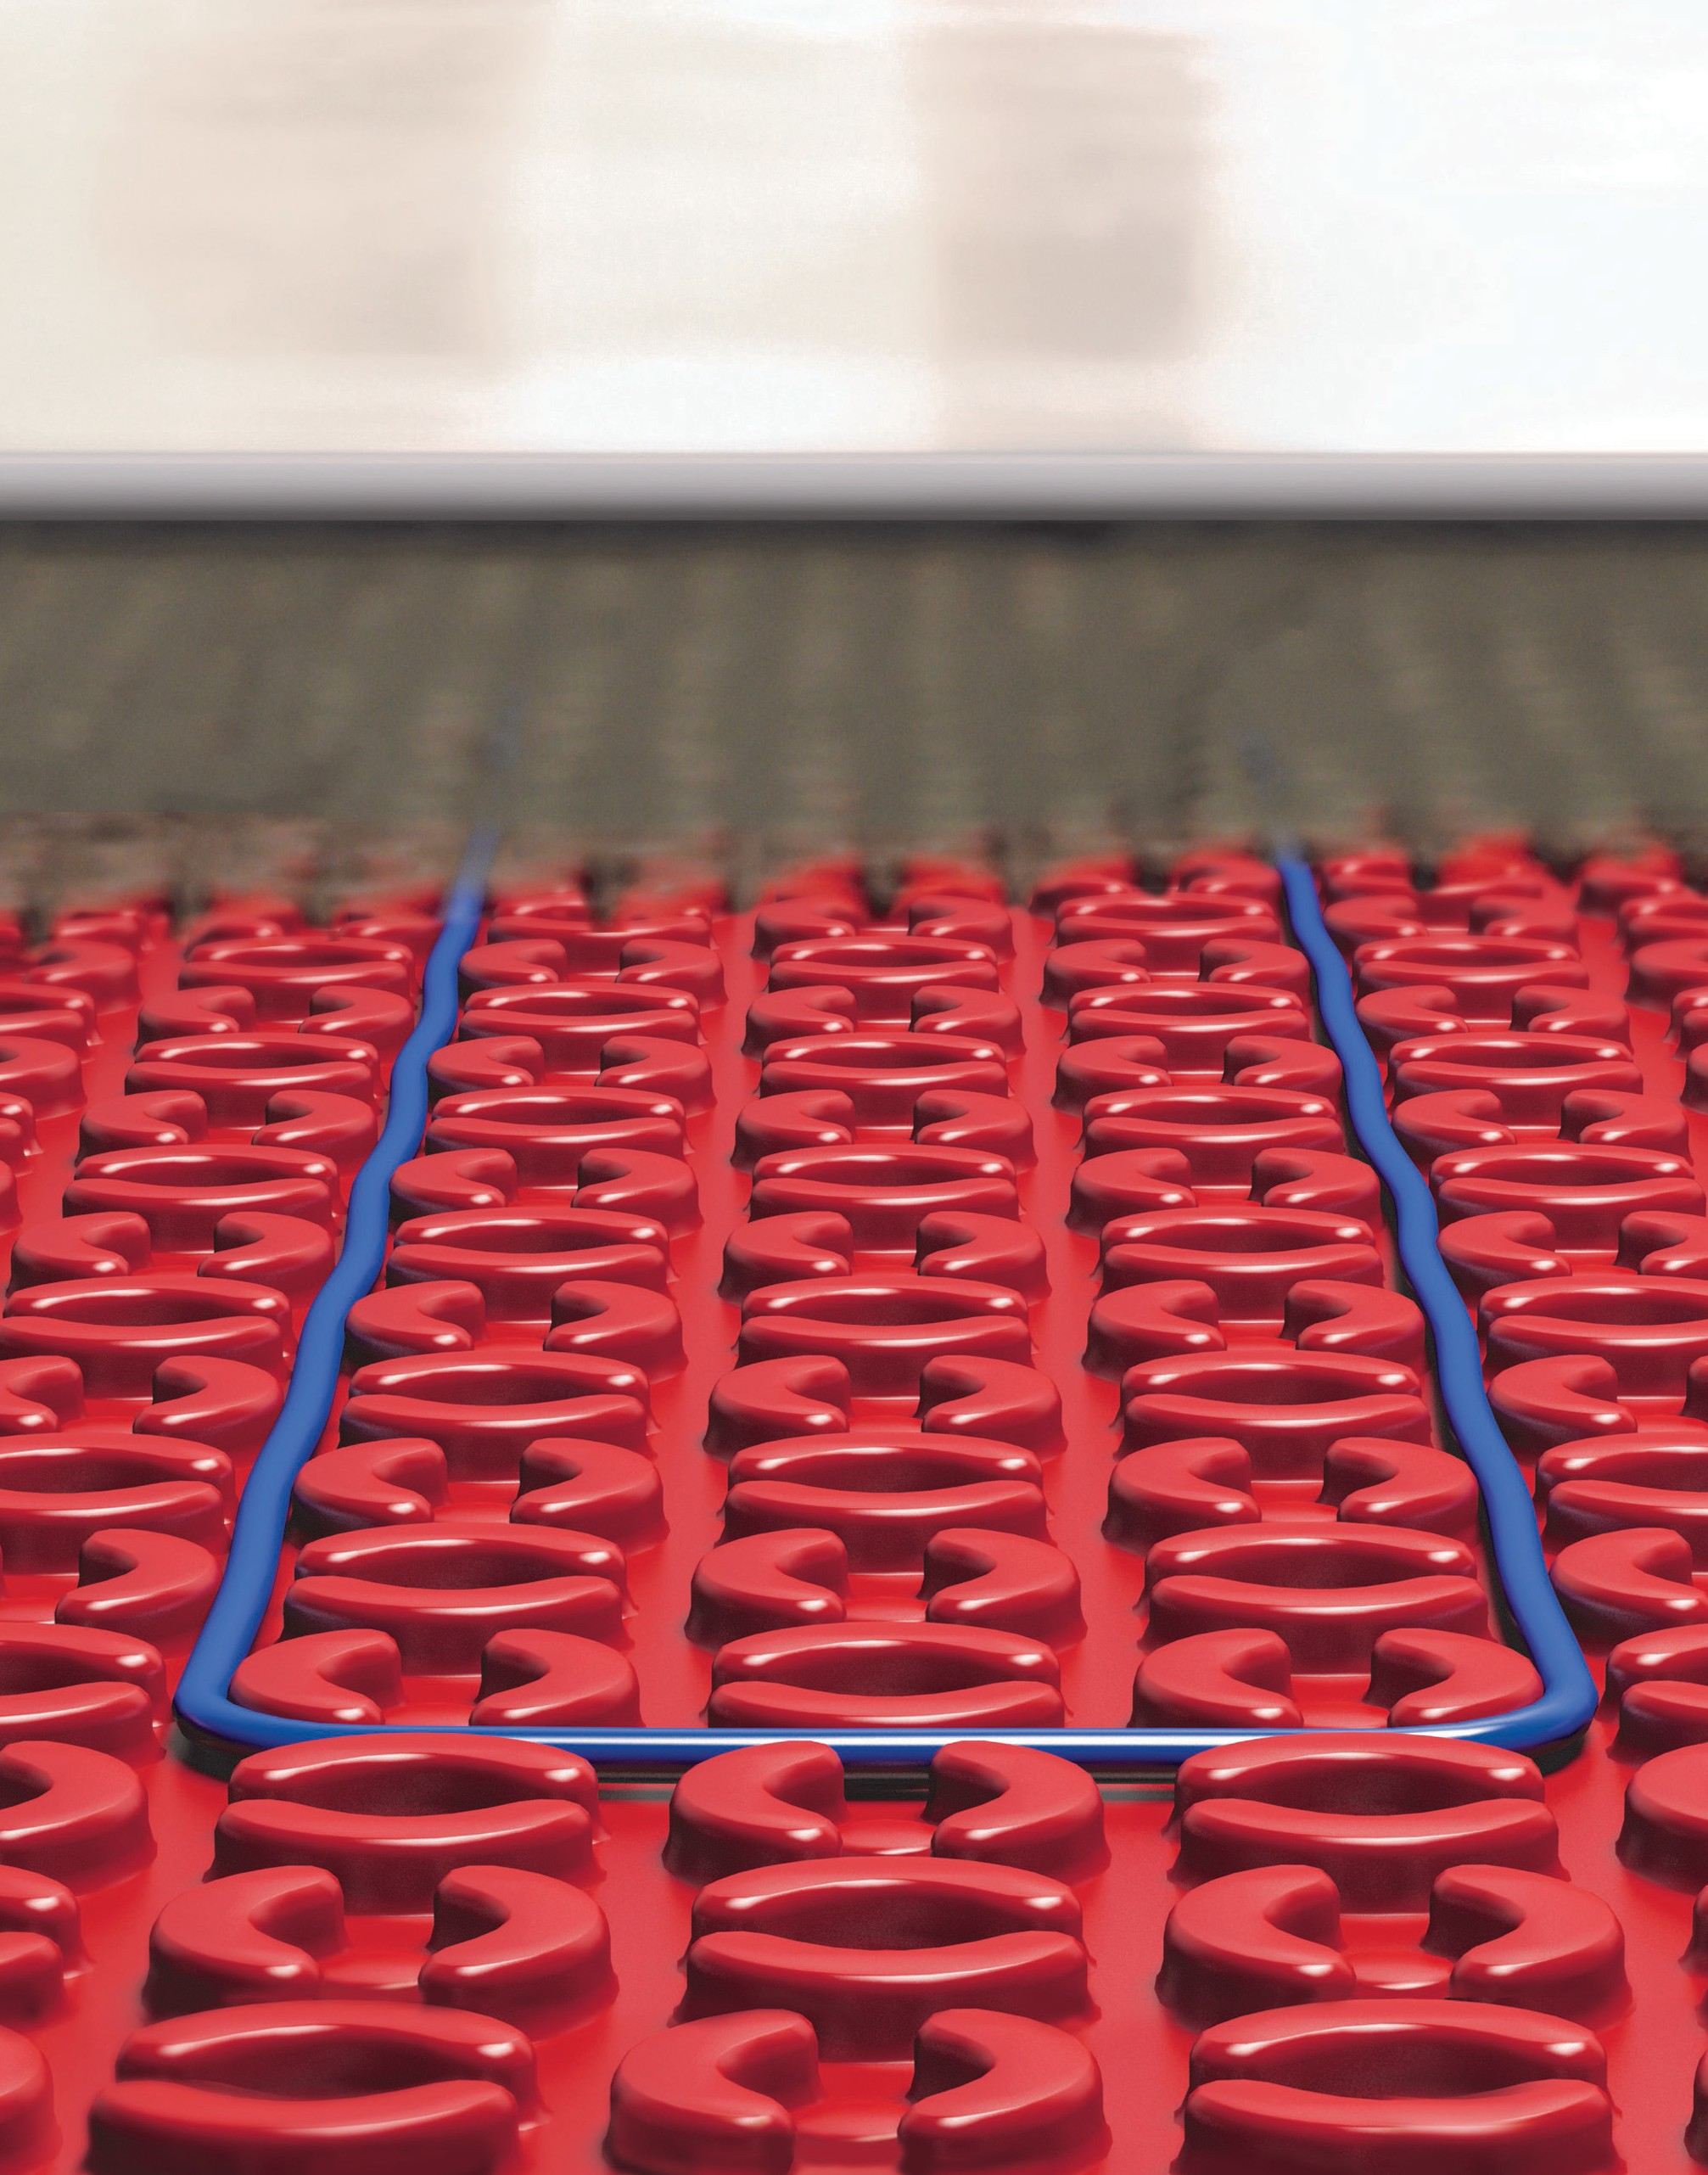 ELECTRIC RADIANT FLOOR SYSTEM
WITH ANTI-FRACTURE MEMBRANE

FOR COMFORT HEATING

OR PRIMARY HEATING

US +1 (888) 927-6333 / CA 1+ (888) 592-7687
ussales@warmup.com www.warmup.com / www.warmup.ca

Part 1 - General

1.1 Section Includes

- Heating System in Anti-Fracture membrane.

- Digital programmable thermostat with probe type thermistor sensor.

- Electric radiant floor heating system components, accessories, and associated installation materials.

1.2 Related Sections

- 013300 – Submittal Procedures
- 014100 – Regulatory Requirements
- 014300 – Quality Assurance
- 017000 – Execution and Closeout
- 040513 – Masonry Mortaring
- 093000 – Tiling
- 061000 – Rough Carpentry
- 093100 – Thin-Set
- 096000 – Flooring
- 260620.16 – Electrical
- 262200 – Low Voltage

1.3 References
- National Electrical Code ( NEC )
- Canadian Standards Association ( CSA )
- Underwriter’s Laboratory ( UL )
- Tile Council of North America ( TCNA )
- American National Standards Institute ( ANSI )
- Warmup Floor Heating System Installation Manual and Install Video

Part 1 - General (Continued)

1.4 Submittals
- Submit under provisions of Section 013300
- Provide General Contractor, Architect, MEP Engineer, and Owner with all the Manufacturer’s product data sheets, warranty, and installation instructions.
- Provide General Contractor, Architect, MEP Engineer, and Owner with all relevant Shop Drawings, Samples, Mock-Ups, and Electrical Schematics.

1.5 Quality Assurance

- Manufacturer Qualifications & Services:
  - 20 years of experience (minimum) with electric radiant floor heating systems.
  - Anti-fracture membrane, thermostats, sensors, relays, and related items shall be provided by one manufacturer to comprise a system.
  - Must operate its own testing facility to provide project specific and/or product specific field data.
  - Must be able to provide on-site project support. This may include but is not limited to Pre- installation Conference where attendance of installation material manufacturer, tile supplier, tile installer and installers of related work is required. Review installation procedures and coordination required with related work.
  - Must provide 24/7 technical installation support and free design assistance.
- Installer Qualifications:
  - Must have verifiable experience successfully completing projects of similar size, and /or has been trained or certified by a manufacturer’s representative.
  - When combined with electric heating system, a licensed electrician shall complete all electrical rough-in, and electrical connections required to complete the system installation.
- Pre-Installation Meetings:
  - Coordinate work with other trade representatives (general, electrical, flooring, and other trade contractors) to verify areas of responsibility (scope of work) with factory representative.
  - Review project timeline and construction deadlines to ensure project will comply with all manufacturer’s installation instructions and warranty requirements.
- Regulatory Requirements and Approvals:
Electric Radiant Floor Heating System: if required, provide a radiant floor heating system that complies with the following requirements:
  - Heating cables for installation in cement-based mortar over wood subfloors shall be listed to UL 1673 and CSA-C22.2 No. 130-03.
  - System must meet ASTM 118.12 Anti-fracture membrane requirements and pass all 14 levels of the C627 Robinson test over plywood at 19” beam spacing.

1.6 Delivery, Storage and Handling

- Deliver materials in manufacturer’s original, unopened, undamaged containers with identification labels intact.
- Store materials protected from exposure to harmful site conditions, and in an area protected from vandalism and theft.

Part 2 - Products

2.1 Manufacturer
- Warmup Inc., a division of Warmup PLC (UK) US +1 (888) 927-6333 / CA 1+ (888) 592-7687 52 Federal Road, Unit 1F, Danbury, CT 06810 www.warmup.com/www.warmup.ca

- Substitution requests must be approved 15 days prior to bid due date.
Alternative equipment manufacturer must provide all relevant product data sheets, warranty, installation instructions, shop drawings, samples, and electrical schematics.
Alternative equipment must meet specified material standards.

2.2 Electric Heated Floor with anti-fracture Membrane
Warmup DCM-PRO System
  - Membrane must be no thicker than ¼” and meet all criteria of the ASTM 118.12 anti-fracture standards. It must pass all 14 levels of the C627 Robinson test over plywood on 19” beams.
    - Membrane should be composed of high-density polypropylene designed to secure
heating cables in place with an anchoring fleece or pressure sensitive adhesive attached to the underside.
    - Membrane should allow the use of modified adhesives both on top and below as well as leveling compounds above to permit the installation of small-format tiles and mosaics.
  - The Warmup DCM-PRO cable has an output of 14w/sqft at 3-peg spacing on membranes and has been successfully proven to provide Primary Heating outputs in independent testing
    - Cable must be built with inner ETFE jackets for high heat outputs and PVC outer jackets for installation flexibility and fit inside membrane.
    - Cable should have a non-prorated 30 year warranty
    - Cable should provide the design flexibility of being spaced at 2 pegs, 2-3 alternates and 3 peg spacings

2.3 Controls, Sensors & Accessories
- The 4iE control series provide a touch-screen interface and a 7-day programmable thermostat. The 4iE-03 & 4iE-04 models are equipped with a built-in Class A GFCI protection. The 4iE-04 model provides WiFi connectivity to operate the heating system via the MyHeating app,
the my.warmup.com portal or third party systems using a Control 4 bridge (provided).
All Warmup thermostats are dual voltage and supplied with a 10ft low voltage floor sensor. Each thermostat can switch up to 15Amps of load. Warmup thermostats come with a 3 year warranty.

- One Circuit Check shall be provided for each mat heater. This device sounds an audible alarm if damage occurs to the Heating Element.

- Insulation may be recommended to provide a thermal break from unheated spaces or concrete slabs. Warmup insulation boards are rigid 6mm boards made of extruded polystyrene foam and coated with a cementitious compound on both sides to ensure adhesion with subfloor
and flooring layers. Insulation should be at least 6mm or 1/4” thick provided with documented performance metrics and tested in accordance with ASTM CI 77.85.
All insulation layers must be mold proof, fire proof and have a compression strength of at least 36lbs/sq inch. Insulation layers should not consist of flexible material such as cork, felt or rubber- based compounds.

Part 3 - Execution

3.1 Manufacturer’s Instructions

A. Comply with manufacturer’s product data, including product technical bulletins, installation instructions and design drawings.

3.2 Examination & Preparation

- Installer shall verify field measurements are as shown on Shop Drawing(s).

- Any revisions needed to Shop Drawing(s), or product provided, must be corrected prior to proceeding with the installation.

- Prepare your subfloor, as per the standard guidelines set forth by the Tile Council of America. Remove any nails, staples, or other sharp objects, that may damage the heating mat.

- Installer shall verify that the required power is available in suitable location, and ready for use.

3.3 Installation

A. Complete installation must conform to appropriate manufacturer’s installation instructions, National Electrical Code, and appropriate local codes.

3.4 Field Quality Control

- Test each cable for ohms with the Warmup Alligator before, during and after the installation of the floor covering. Record these values on the warranty form available online or/and provided at the end of the Warmup Installation Manual.

- Prior to connection to the thermostat, test the mat’s insulation resistance with Megger or Mega-Ohm meter.

- Start-up (first-time activation) must wait for the mortar to be fully cured. This time can range from 3 – 28 days (deferring to the manufacturer of the mortar).

- During “Start-Up”, voltage and amps should be tested by a licensed electrician

- All testing records should be copied and provided to the Owner.

